

IBM DATA ANALYTICS INTERNSHIP ASSIGNMENT-1

LAVISH YADAV

21BCE7046

Lecturer-Indra Sir

**Now the table changes that I have done**

**1. I have deleted the Invoice ID**

**2. Make a new row by the formula Original Price = Total-quality*unit value**

**3. Split the Date into Year Month Date Week**

**Output-**

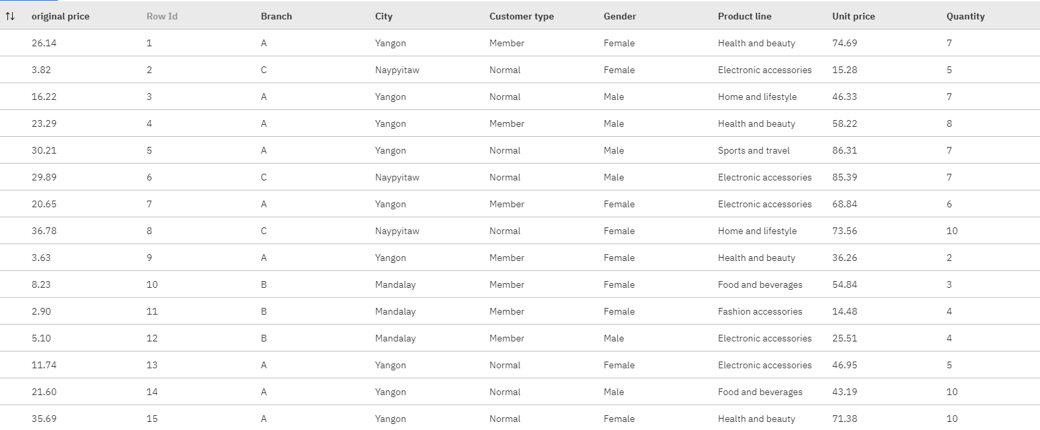

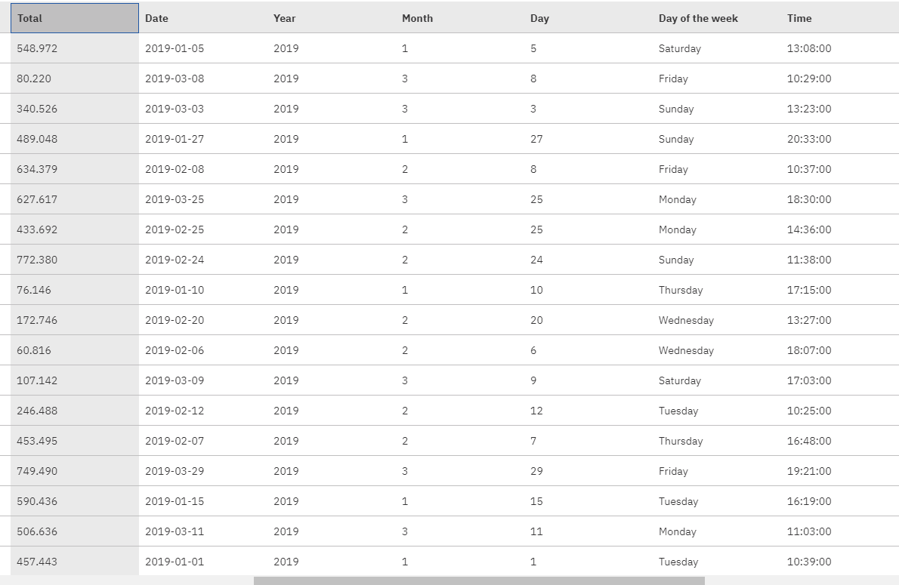

**Now let us see the Visualizations**

**1. Bar Plot**

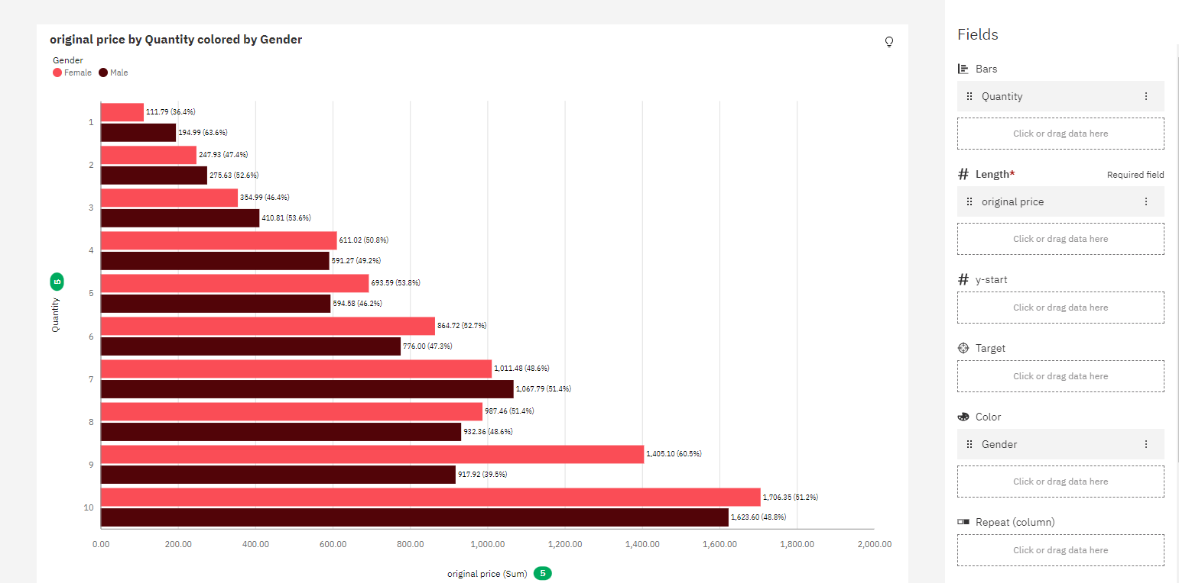

**2. Pie Chart**

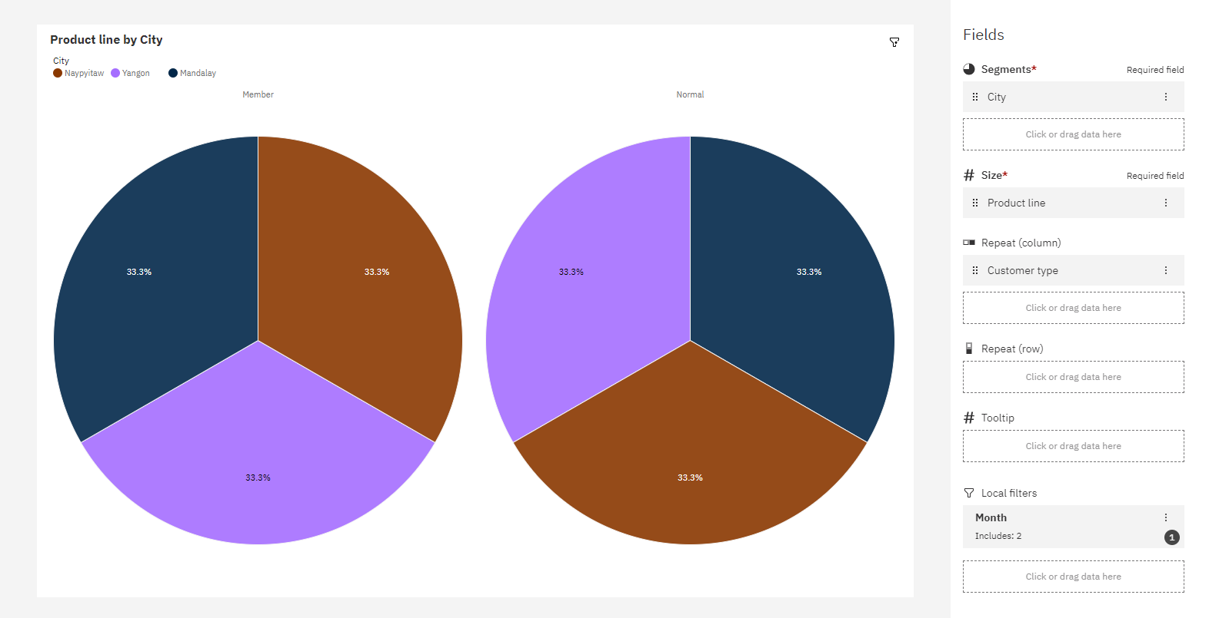

**3. Line Chart**

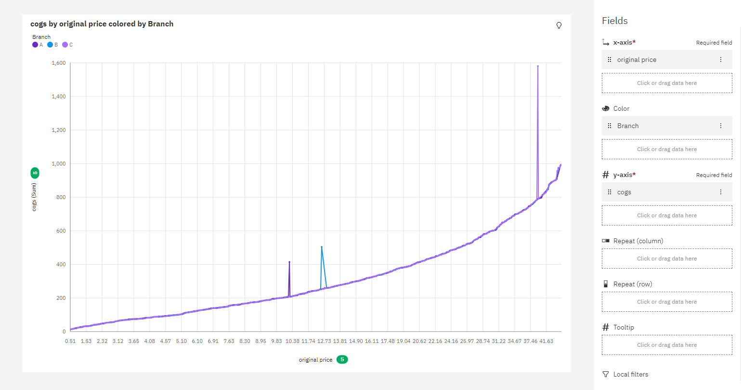

**4. Line and Column**

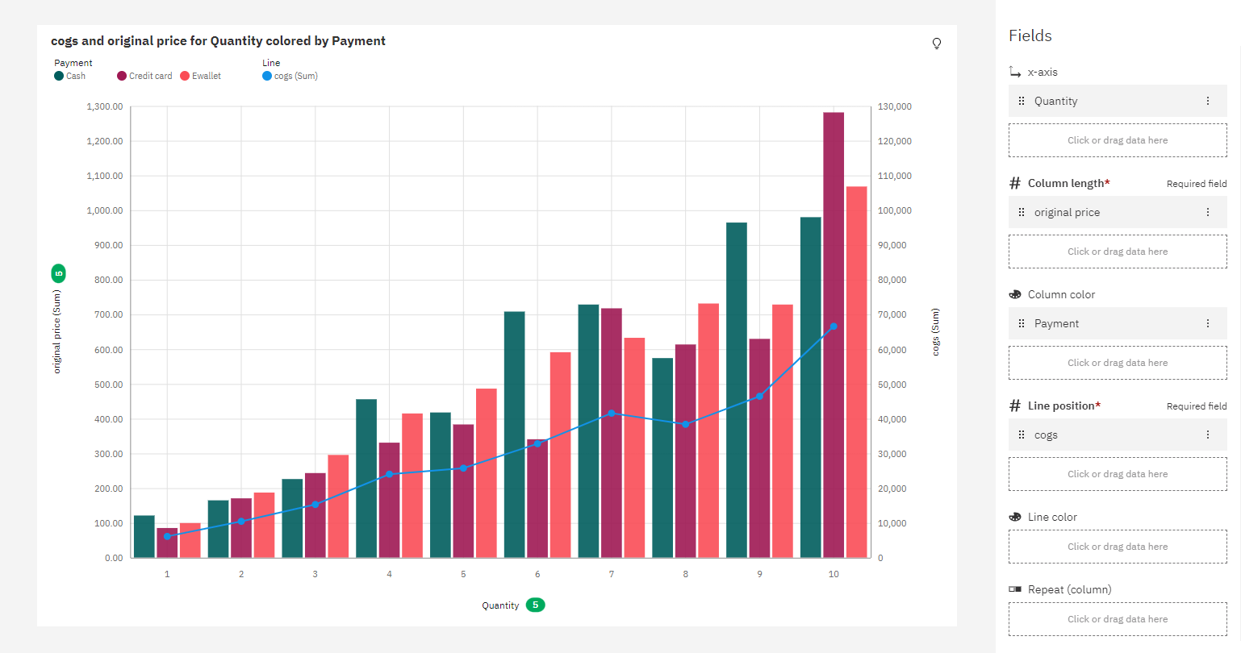

**5. Stacked Bar**

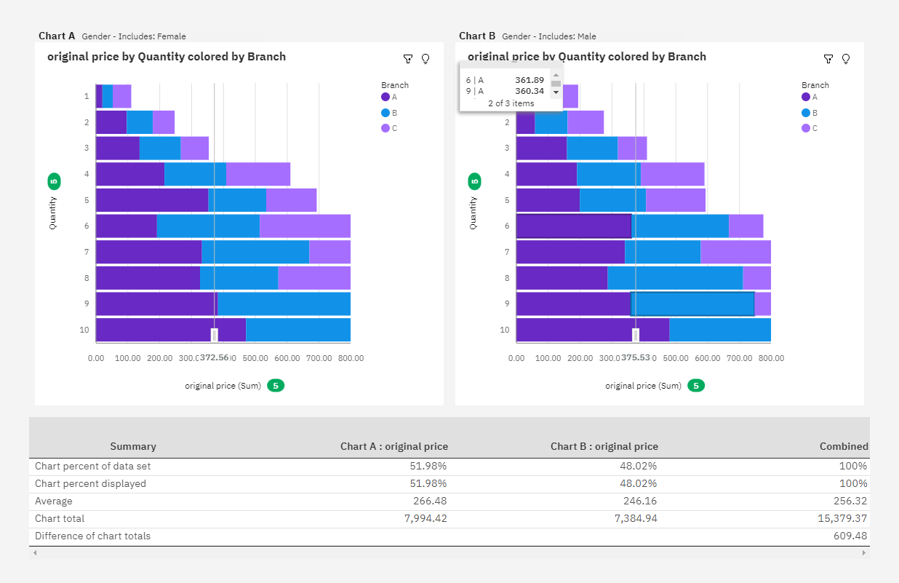

**6. Networking**

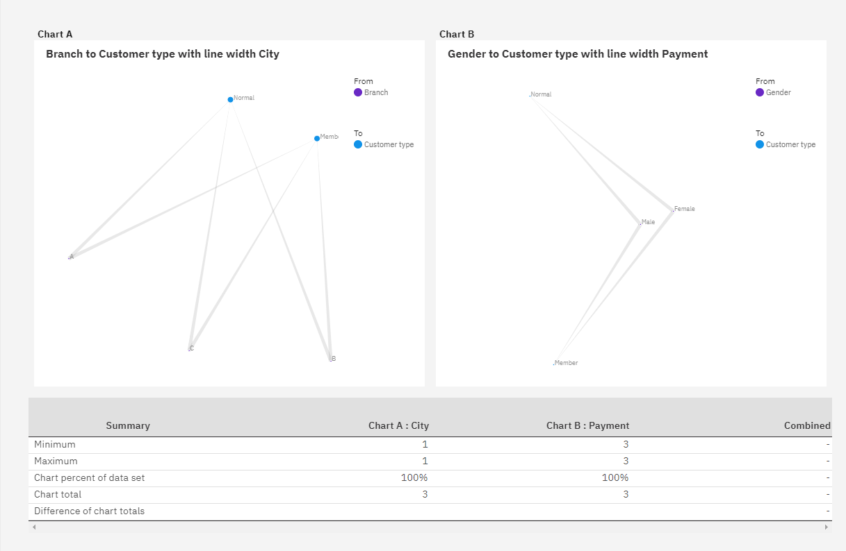

**7. Area Plot**

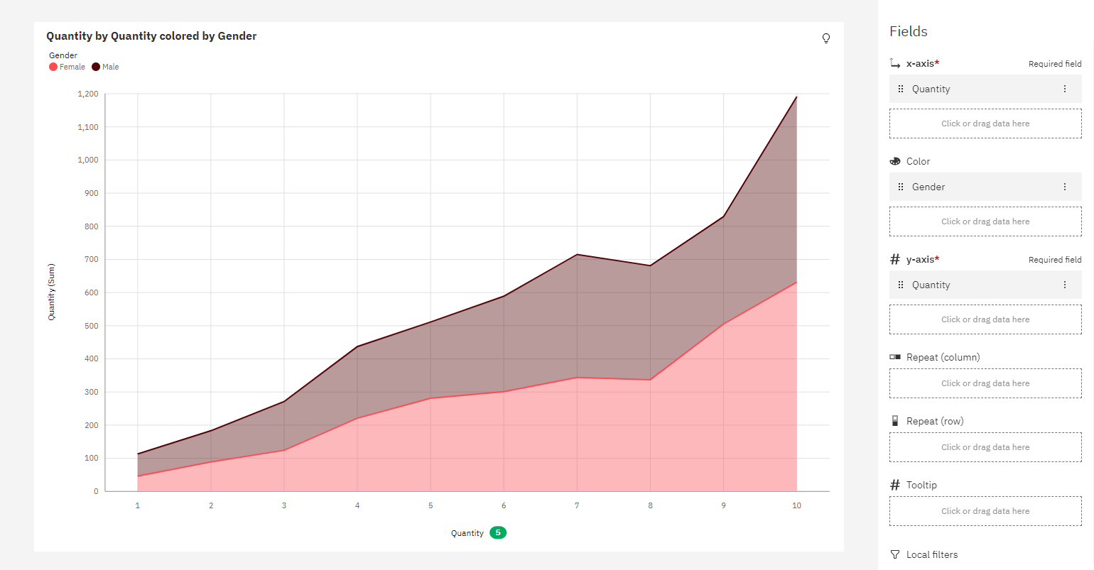

**8. Word Cloud**

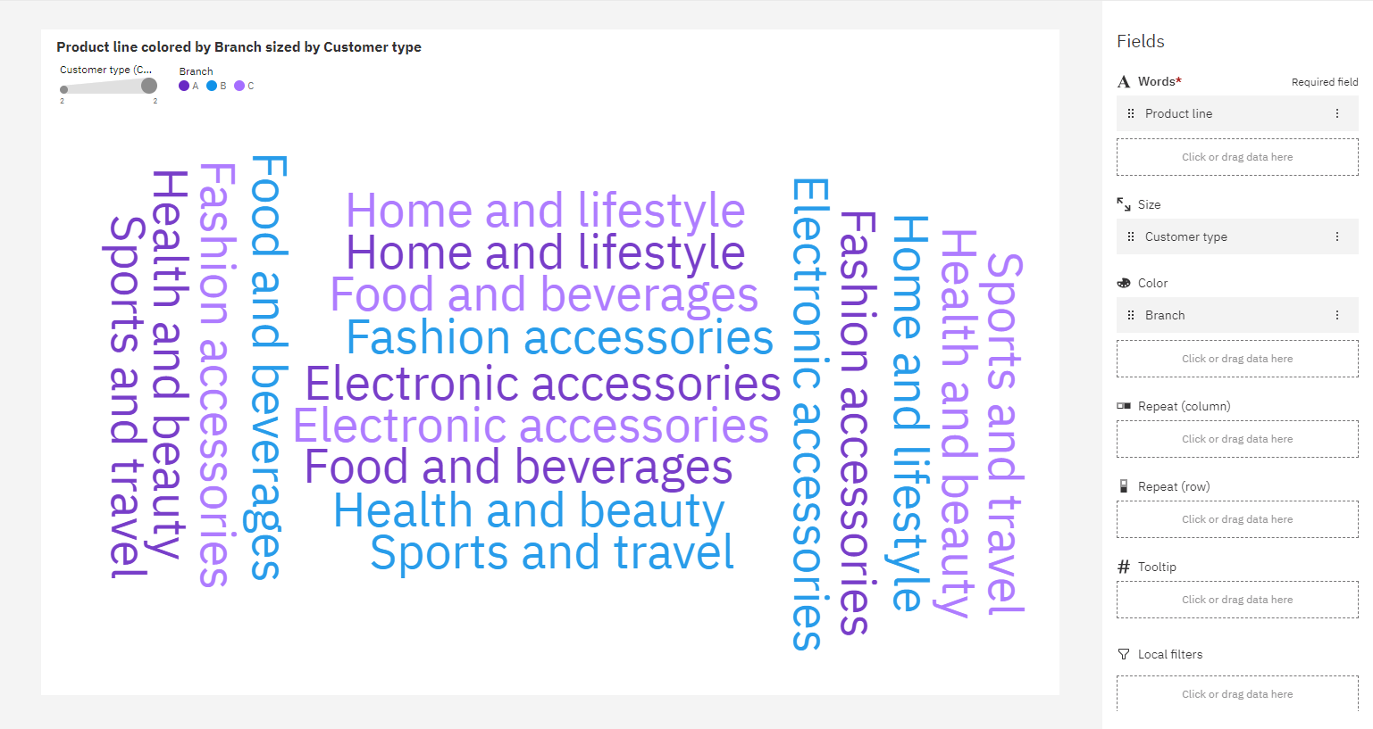

**9. Water Fall**

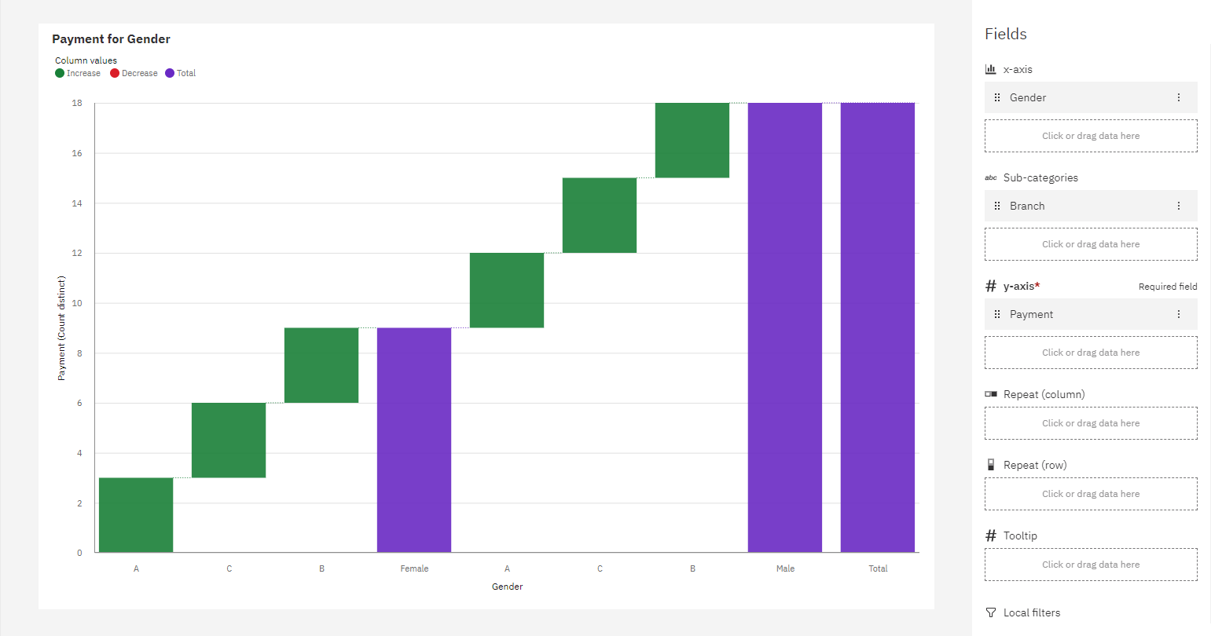

**10. Radial Chart**

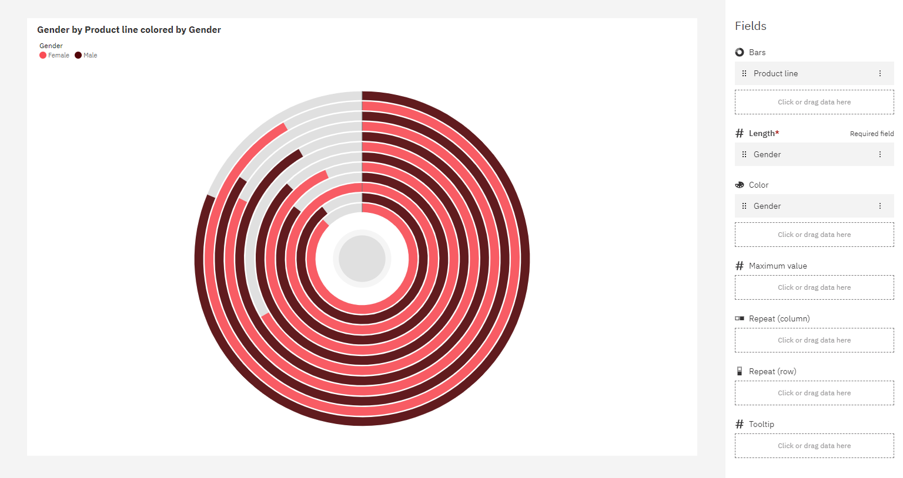

**11. Bubble Chart**

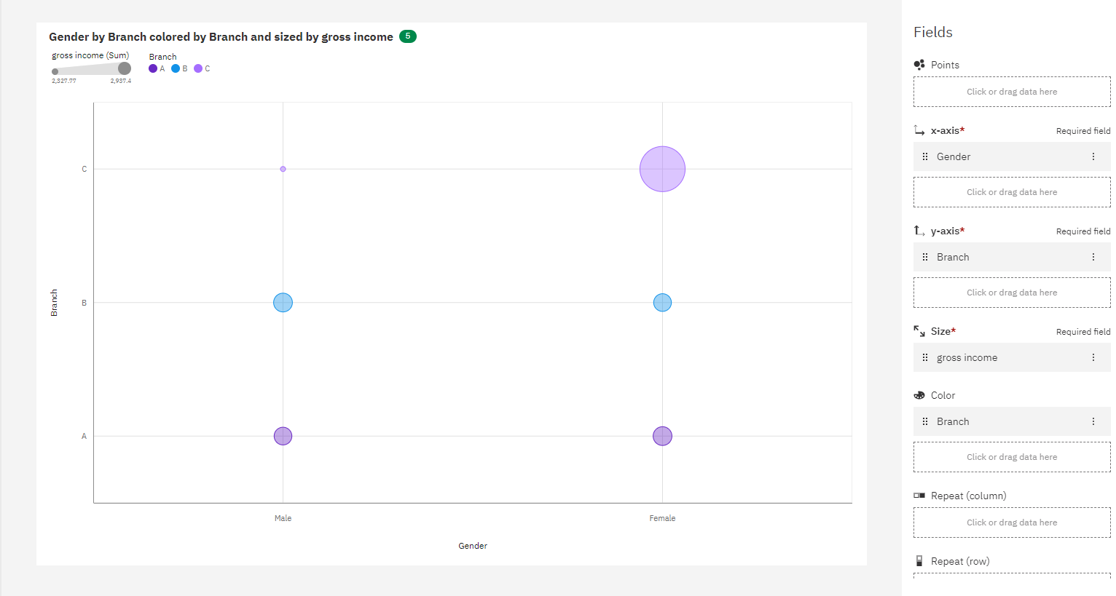

**12. Hierarchy Bubble Chart**

**S**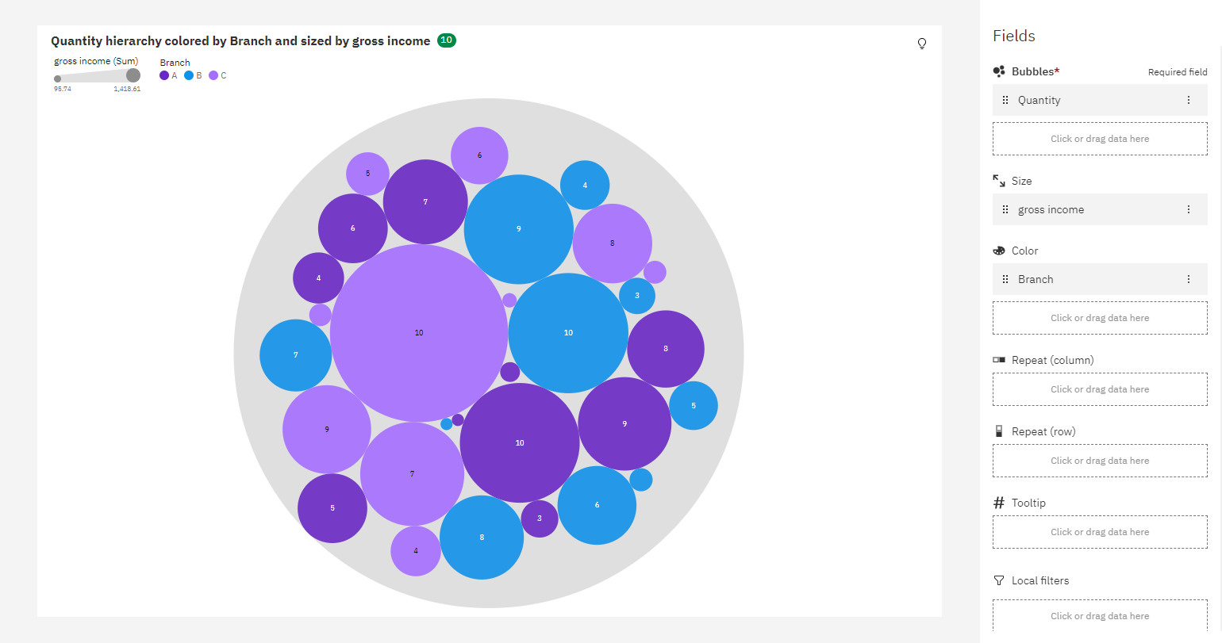

**These are some Visualizations from the datamodule**